**Impact of COVID-19 on Travel (CSCI E-101 Thanksgiving Challenge)**

Ashwin Pillai, Syukri Shukor, Teena Thankachan

**Research Question(s)**

1. Did COVID-19 impact domestic travel during the Thanksgiving holiday in 2021.
2. How does TSA traveler throughput compare between Pre-COVID (2019), Peak-COVID (2020) and Current (2021)?

**Hypotheses**

We hypothesize that there is a difference in domestic travel in 2021 compared to 2019 and 2020.

**Data Source(s)**

We obtained a [**dataset**](https://docs.google.com/spreadsheets/d/194yVQ6AdW3btXIK_t3LvhCKEi2praUGM/edit?usp=sharing&ouid=102670333289286460218&rtpof=true&sd=true) from <https://www.tsa.gov/coronavirus/passenger-throughput> comparing daily TSA traveler throughput from 11th Nov 2020 - 29th Nov 2021.

**Analysis**

Links are provided to the [**Markdown**](https://drive.google.com/file/d/18J9yp6u_dwESE46O1QhS29NmaT8UO-7u/view?usp=sharing) and [**Python**](https://drive.google.com/file/d/1gABpd5lUl5a4Nr_NIKjr--ZKKcdejB33/view?usp=sharing) files. We defined Thanksgiving as the last 2 weeks of November. For early data analysis, we plotted the slopes of daily TSA travelers in 2019, 2020, and 2021 during Thanksgiving with Spotfire in **Figure 1 (**Figures can be found in [**Supplementary**](https://docs.google.com/document/d/1T27RY0T2f6KajUS78404DsOMo-NmkoXYgLHQWrc_udU/edit?usp=sharing)).

We then performed an ANOVA and pairwise two-tailed Independent t-Test comparing daily travel from 15th - 30th Nov in 2021, 2020, and 2019. The null hypothesis was that there is no difference between the 2 years compared.

**Findings & Conclusion**

One-Way ANOVA

We did a one-way ANOVA test and observed p-value <.05,this implies that there is a significant difference between the 3 groups.

**Anova Result (p-value) is 1.4605962861436873e-18**

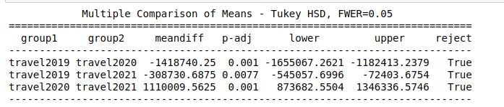

Looking at the Multicompare p-value which is <0.05 outputs we do see that the domestic travel in 2021 is significantly different from 2019 and 2020.

Two-tailed t-Test

| **Years Compared** | **P-value (99% C.I)** |
| --- | --- |
| 2021 vs 2020 | 2.017e-12 |
| 2021 vs 2019 | 0.015 |
| 2020 vs 2019 | 1.4e-14 |

Supported visually by **Figure 2 (**Figures can be found in [**Supplementary**](https://docs.google.com/document/d/1T27RY0T2f6KajUS78404DsOMo-NmkoXYgLHQWrc_udU/edit?usp=sharing))**,** 2021 Thanksgiving travel was significantly higher than 2020, but is significantly lower than 2019 (p-values <0.05). 2020 travel was significantly lower than 2021 and 2019. Therefore, we reject the null hypothesis that there is no difference in Thanksgiving travel in 2019-2021.

In conclusion, using 2019 as baseline, travel was worse during peak-COVID and is recovering in 2021. Both ANOVA T-Test results suggest that 2021 travel during Thanksgiving was not as impacted as COVID as it was in 2020, and is almost comparable to 2019.